

IN THE BUSINESS OF NONPROFITS  
The Management Assessment Process: A GPS for your Nonprofit Organization

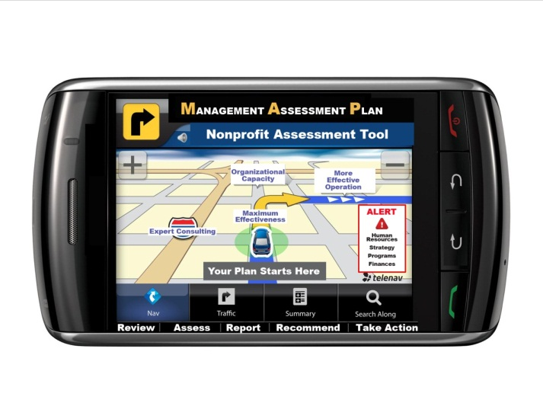

The GPS has made travel simpler, more efficient and less frustrating. The Nonprofit Center offers organizations a navigational system that pinpoints where your organization stands right now and recommends the best way to move forward. It’s called MAP – the Management Assessment Process –and its can serve as the foundation for changes, decisions and planning for your organization’s future.

With MAP, Nonprofit Center experienced consultants conduct interviews and review all the key areas of your organization’s management, governance and operation. They use the information they collect on programs, finances, human resources, funding, communications, and other key elements, to formulate an accurate, quantifiable report card, resulting in a roadmap that details what it will take to overcome obstacles and challenges to move your organization toward achieving its goals.

If your organization is wrestling with issues related to performance, operations and systems and hasn’t been able to move beyond them, MAP is the ideal tool to inform and engage. Armed with a comprehensive plan based on solid data, with the support of a team of objective experts, your organization will have a clearer vision of where it is, where it wants to go, and how to get there.

**Contact us for more information about The Management Assessment Process call, 215-951-1701.**

**The Nonprofit Center at La Salle University School of Business**

**1900 West Olney Ave., Phila., PA 19141 • 215.951.1701 • www.lasallenonprofitcenter.org**