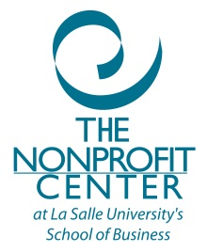

CUSTOMIZED CERTIFICATE
DISCOUNT PACKAGE*

Please submit this form only if you are using the certificate package to register and pay for all classes at one time to receive discount.

Name:
Job Title/Position:
Organization/Affiliation:
Street Address:
City, State, Zip:
Home Telephone:
Business phone:
E-mail:
Certificate Program:

- Customized Certificate: $ (Cost depends on curriculum)

*Membership: (Discount package requires current membership in The Nonprofit Center.)

Organization Address:
City, State, Zip:
Website:

Select the level of membership you wish to join at:

Your Budget | BASIC | MEMBERPLUS
Under $250,000 | $260 | $515
$250,001-$500,000 | $315 | $590
$500,001-$1M | $420 | $740
$1,000,001-$2M | $525 | $890
$2,000,001-$5M | $630 | $1040
$5M or over | $735 | $1190
Individual Membership* | $125 | N/A

*Individual membership is only for those who do not work for a nonprofit.

□ Check box if you are already a Nonprofit Center member. (Please call 215-991-3676 if you need to confirm).

For more information on the benefits of membership, please visit our website.

Please select the dates you wish to attend:

(Please contact Rob Fennell to discuss curriculum – fennell@lasalle.edu or 215-991-3676)

Course Name | Course Date(s)/Location(s) |  | Time

Please send the completed form to:

The Nonprofit Center
1900 W. Olney Ave.
Philadelphia, PA 19141

By fax: 215-991-2967 By email: fennell@lasalle.edu

Once we have received the completed form and processed your application we will contact you by email to confirm your enrollment on the certificate and provide instructions regarding making a payment.

